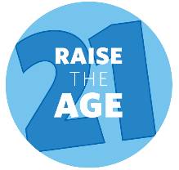
Raising the Age of Juvenile Jurisdiction Reduces Recidivism
Young people’s problematic behavior peaks at age 18 and 19. It is imperative that we recognize that successfully reducing recidivism is directly tied to young people’s ability to meet key youth developmental milestones. The juvenile system’s focus on accountability through rehabilitation and positive youth development is directly tied to lower recidivism rates. Based on a review of six studies on the effects of prosecuting juveniles as adult on subsequent violent offending, the CDC concluded that otherwise similar adolescents had a 34 percent higher felony re-arrest rate when they were processed in court as adults compared to those arraigned as juveniles.

Recidivism among young people incarcerated in the adult correctional system is more than double the recidivism of similarly aged youth released from Department of Youth Services commitment. Teens and young adults incarcerated in Massachusetts’ adult correctional facilities have a 55% re-conviction rate, while teens exiting DYS commitment have a re-conviction rate of 22% (figure 1).

Young people in the adult system have the highest recidivism of any age group, and similar young people in the juvenile system have the lowest recidivism of any age group (figure 2). DYS has been successful in reducing its recidivism rate following almost four decades of reforms, building in an emphasis on treatment and promoting policies whose primary goal is to ensure young people’s healthy and positive development into adulthood.

Criminal (adult) legal system-involved young people are also the costliest population to taxpayers. According to Council of State Government’s analysis of Massachusetts data, “young people have longer lengths of stay than other groups, making them the costliest group of recidivists.”

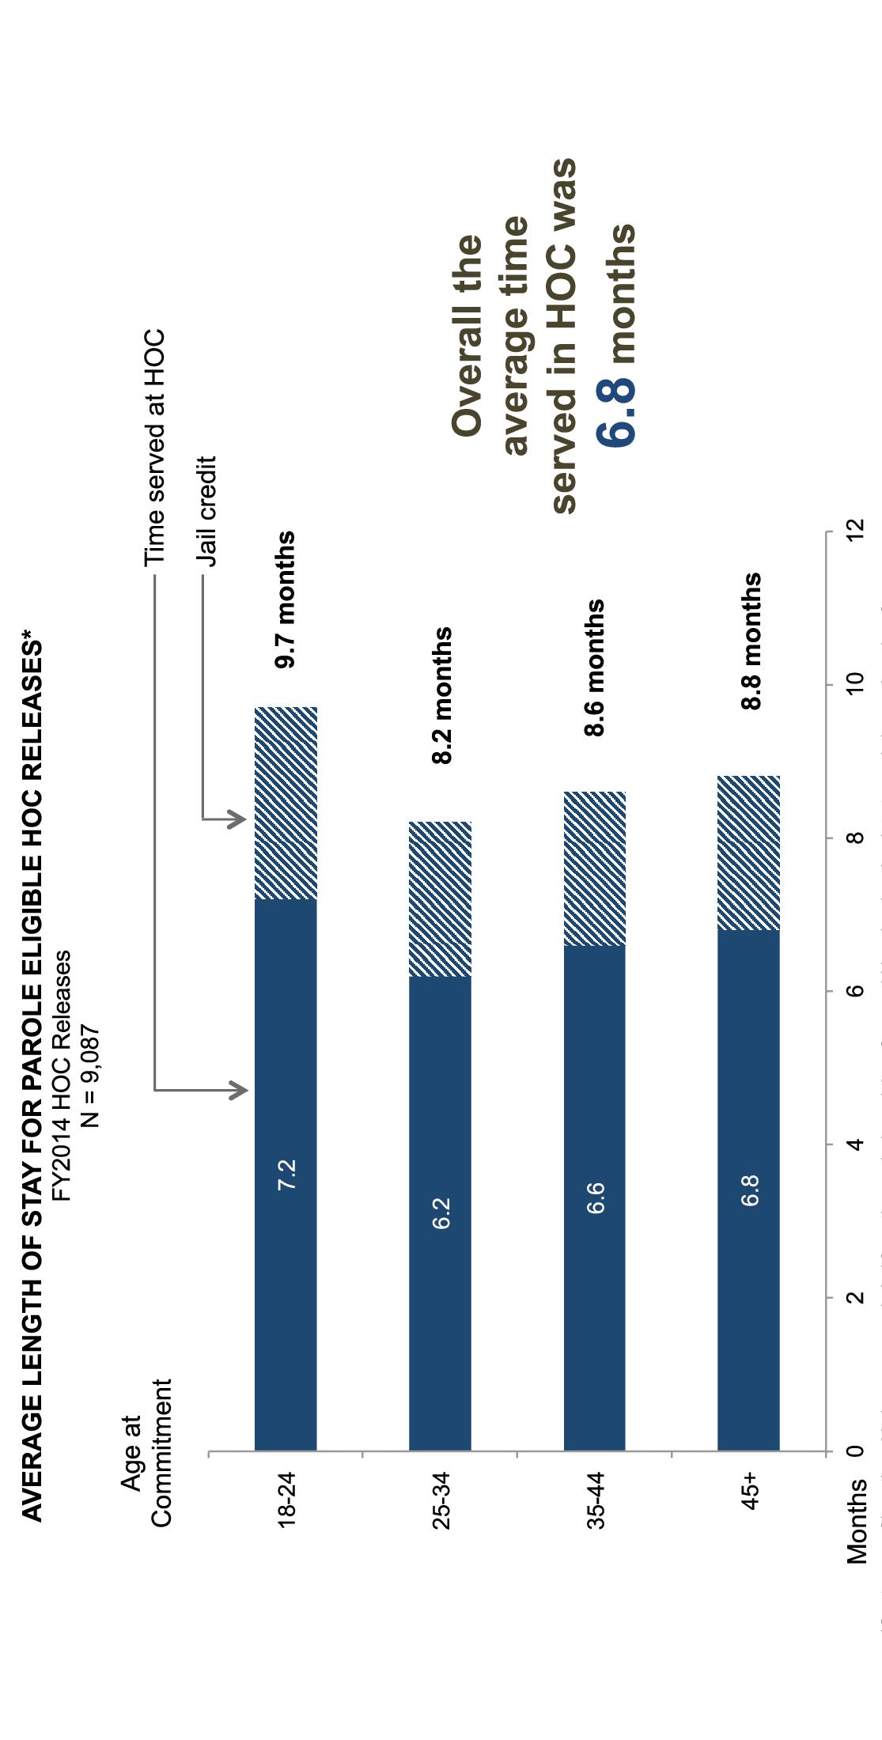
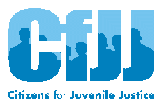 | For more information, please contact Sana Fadel, sanafadel@cfjj.org  Citizens for Juvenile Justice, 44 School Street, Suite 415, Boston MA 02108

Loeber, Rolf, and Rebecca Stallings, “Modeling the Impact of Interventions on Local Indicators of Offending, Victimization, and Incarceration,” in Young Homicide Offenders and Victims: Risk Factors, Prediction, and Prevention from Childhood, eds. Rolf Loeber and David P. Farrington, New York: Springer, 2011: 137-152. Accessed at https://nij.ojp.gov/topics/articles/juvenile-delinquency-young-adult-offending
Centers for Disease Control and Prevention. Effects on Violence of Laws and Policies Facilitating the Transfer of Youth from the Juvenile to the Adult Justice System. MMWR 2007;56 (No. RR-9). Available at https://www.cdc.gov/mmwr/pdf/rr/rr5609.pdf
Council of State Governments Justice Center, “Justice Reinvestment in Massachusetts: Policy Framework,” February 21, 2017. Available at https://csgjusticecenter.org/jr/massachusetts/publications/justice-reinvestment-in-massachusetts-policy-framework/
Re-arraignment rate is 46% after DYS commitment compared to 76% after incarceration at county jails.
Department of Youth Services, “Juvenile Recidivism Report for Youth Discharged During 2014” November 19, 2018. Available at https://www.mass.gov/files/documents/2018/12/17/recid2018.docx
Council of State Governments Justice Center, “Justice Reinvestment in Massachusetts: Working Group Meeting 3 Interim Report,” July 21, 2017. Available at https://csgjusticecenter.org/publications/justice-reinvestment-in-massachusetts-third-presentation/
Department of Youth Services, “Juvenile Recidivism Report for Youth Discharged During 2016” December 15, 2020. Available at https://www.mass.gov/doc/dys-2020-recidivism-report/download.
Council of State Governments Justice Center, “Justice Reinvestment in Massachusetts: Working Group Meeting 3 Interim Report,” July 21, 2017. Available at https://csgjusticecenter.org/publications/justice-reinvestment-in-massachusetts-third-presentation/

